### How to Use the Robotic Swarm Control Lab Laser Cutter

### Cleaning the optics(this must be done each day the cutter is used)

The laser cutter is a precision instrument that needs daily cleanings.

There are 4 mirrors/lenses along the optical path.

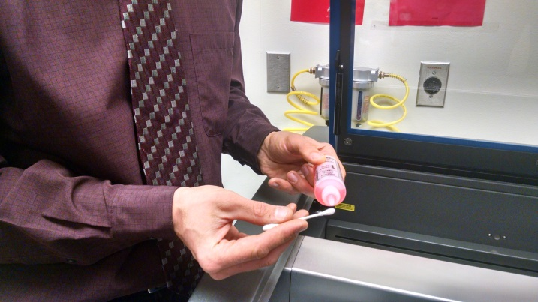 add cleaning fluid to a new Q-tip

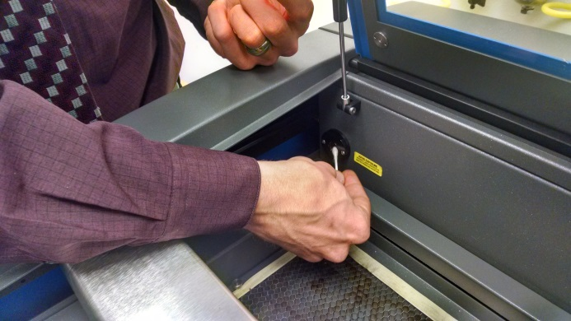clean the optical window at the back left

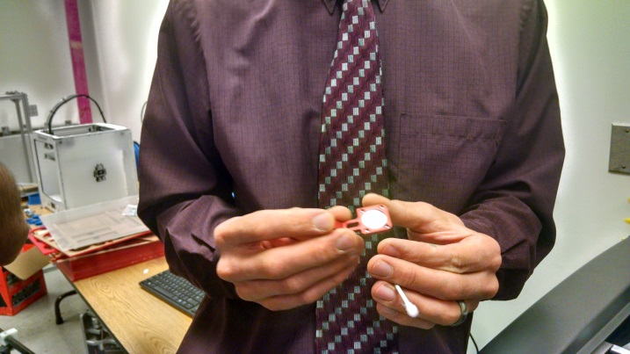the next mirror is at the left [add image] , under the silver magnetic cover. Pull this one out and clean with the other side of the Q-tip

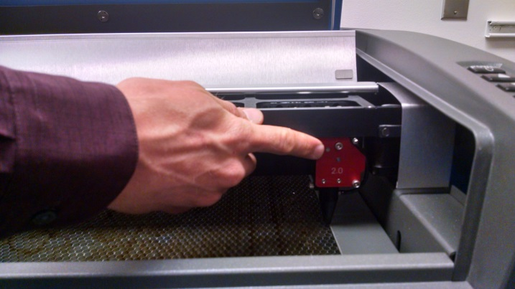The last optics are at the right under the silver color. Loosen both thumbscrews, and remove the lens assembly.

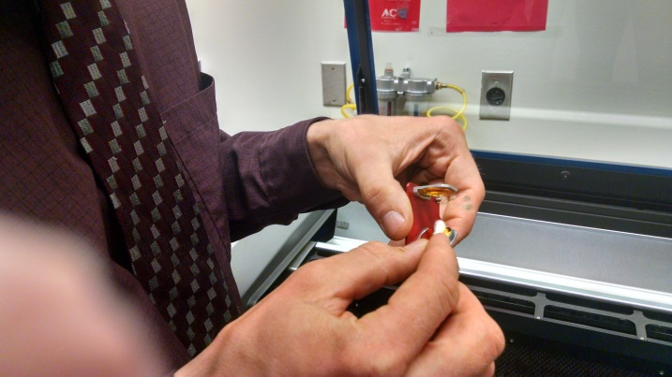 clean the mirror and both sides of the lens. Then replace the optics and tighten the thumbscrews.

## Draw your part (in AutoCAD or Inkscape or other drawing program)

After you draw the part, make sure all the lines are set to 0mm. Color the lines in the order you want to print.

In Inkscape, make the lines 0.001inches (Ctrl+Shift+F), then save as a pdf, then open the pdf in Adobe and print it on the 3.50 printer.

To print, make a rectangle that is the size of the cutting region: 24”x12” (which is 609.6mmx 304.8mm)

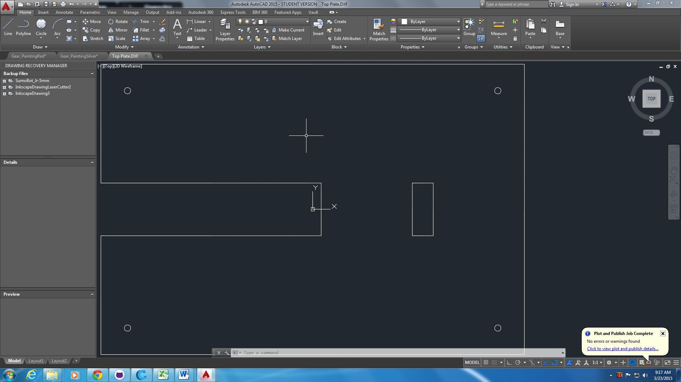



Use rectangle tool (REC), enter first dimension, click tab, second dimension

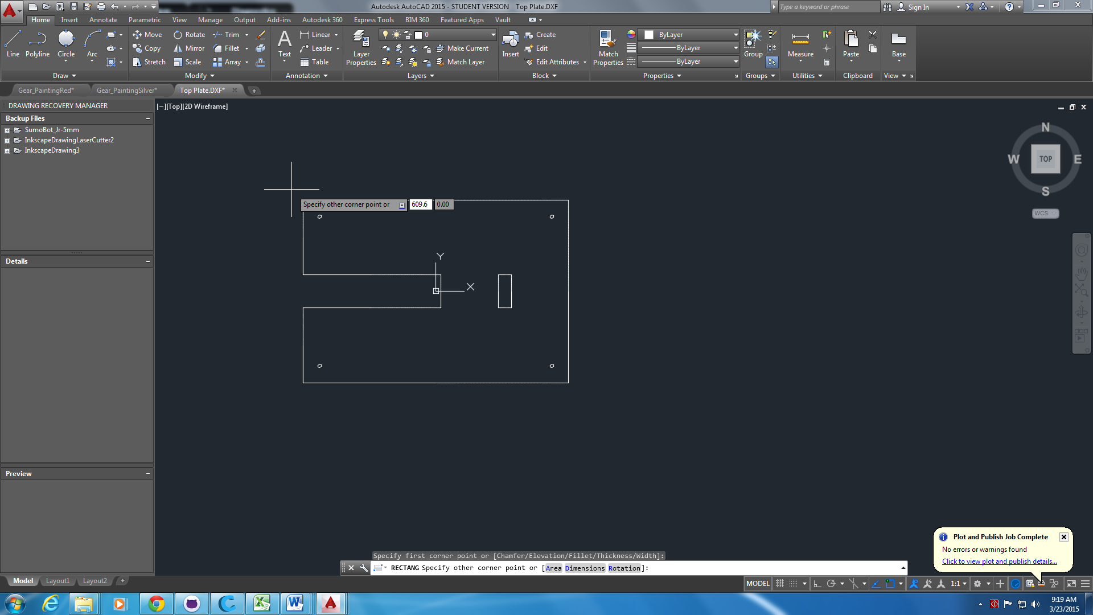

Zoom out to see the whole rectangle (you may need to type REGEN at the command prompt)

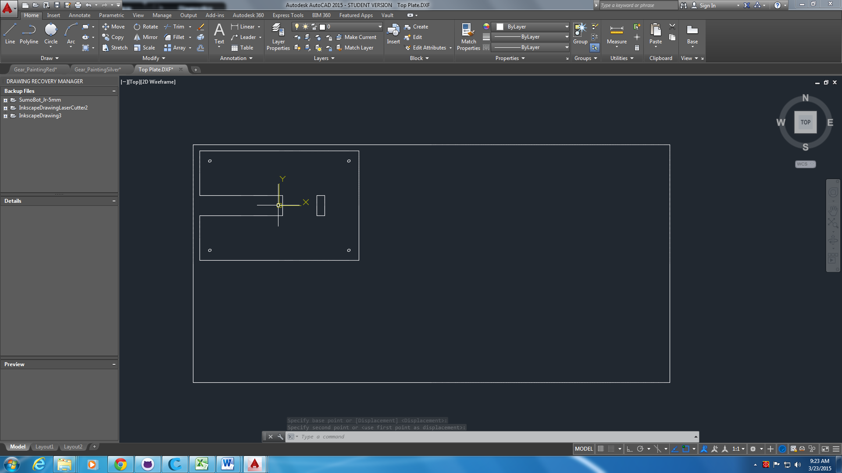

Make the lineweights 0mm

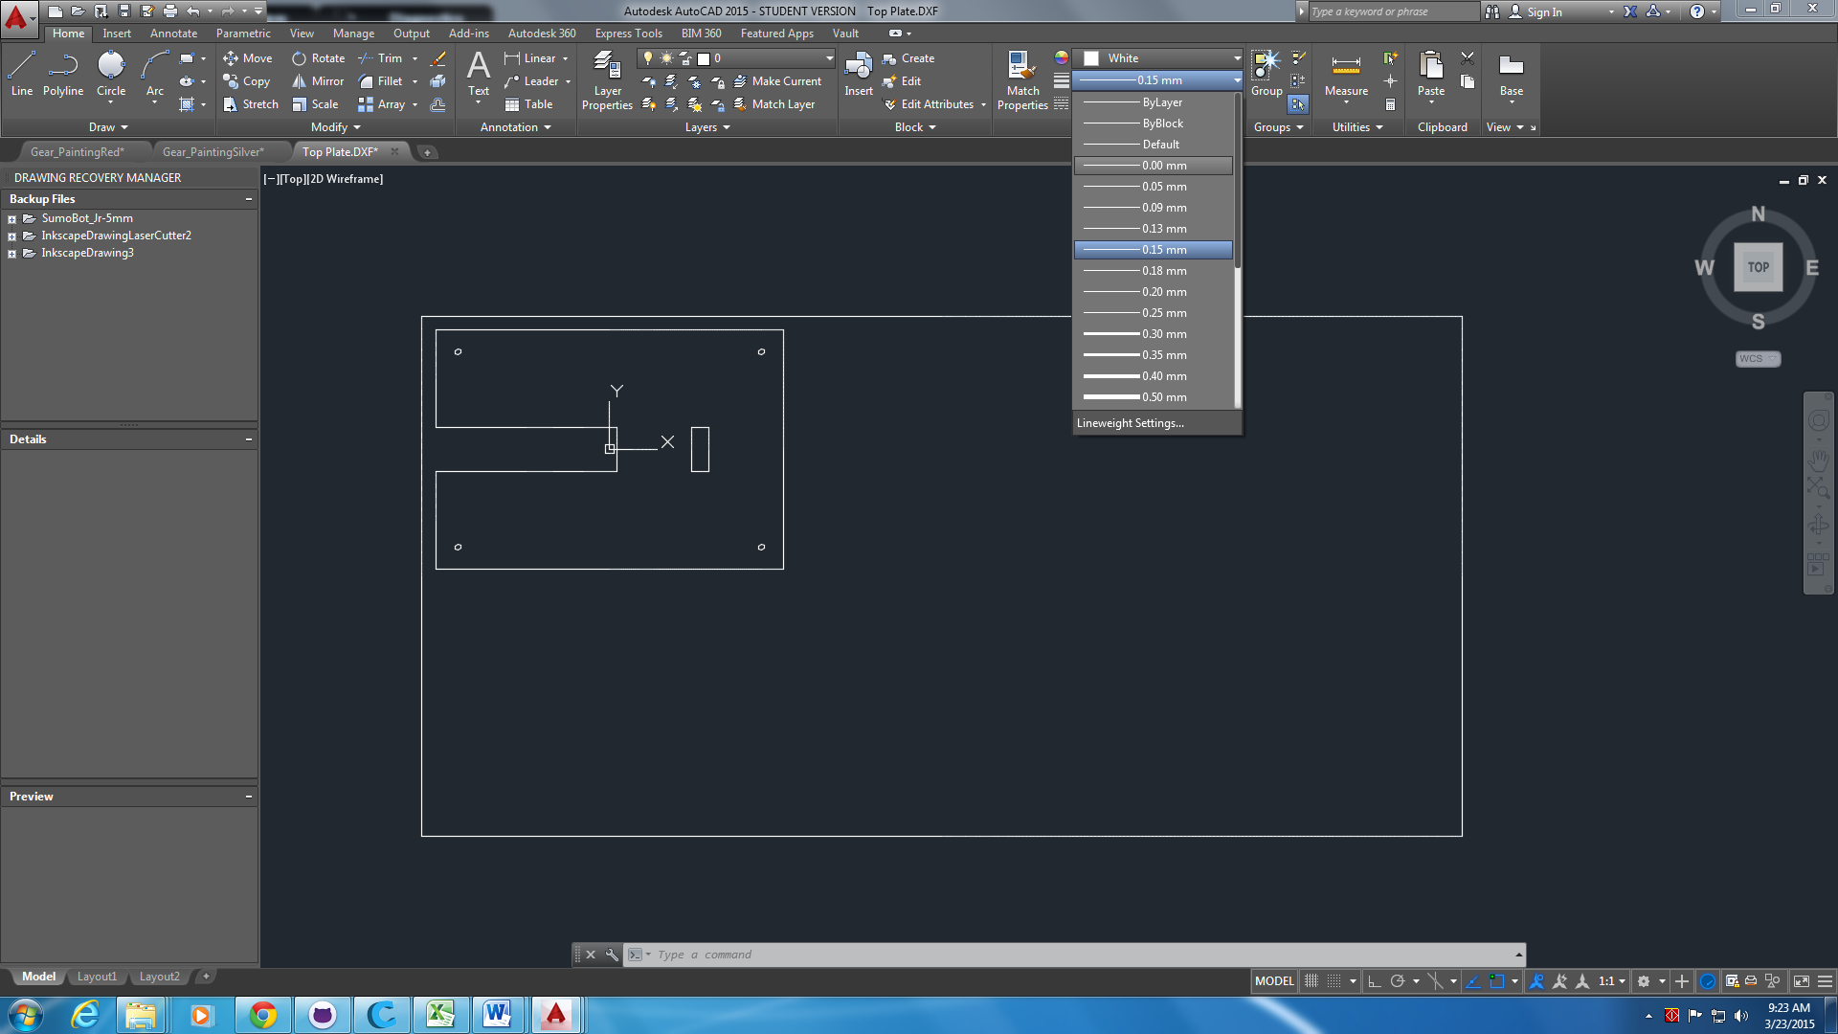

Make line color of the part to cut one of the index colors (red, Cyan, Yellow, etc.):

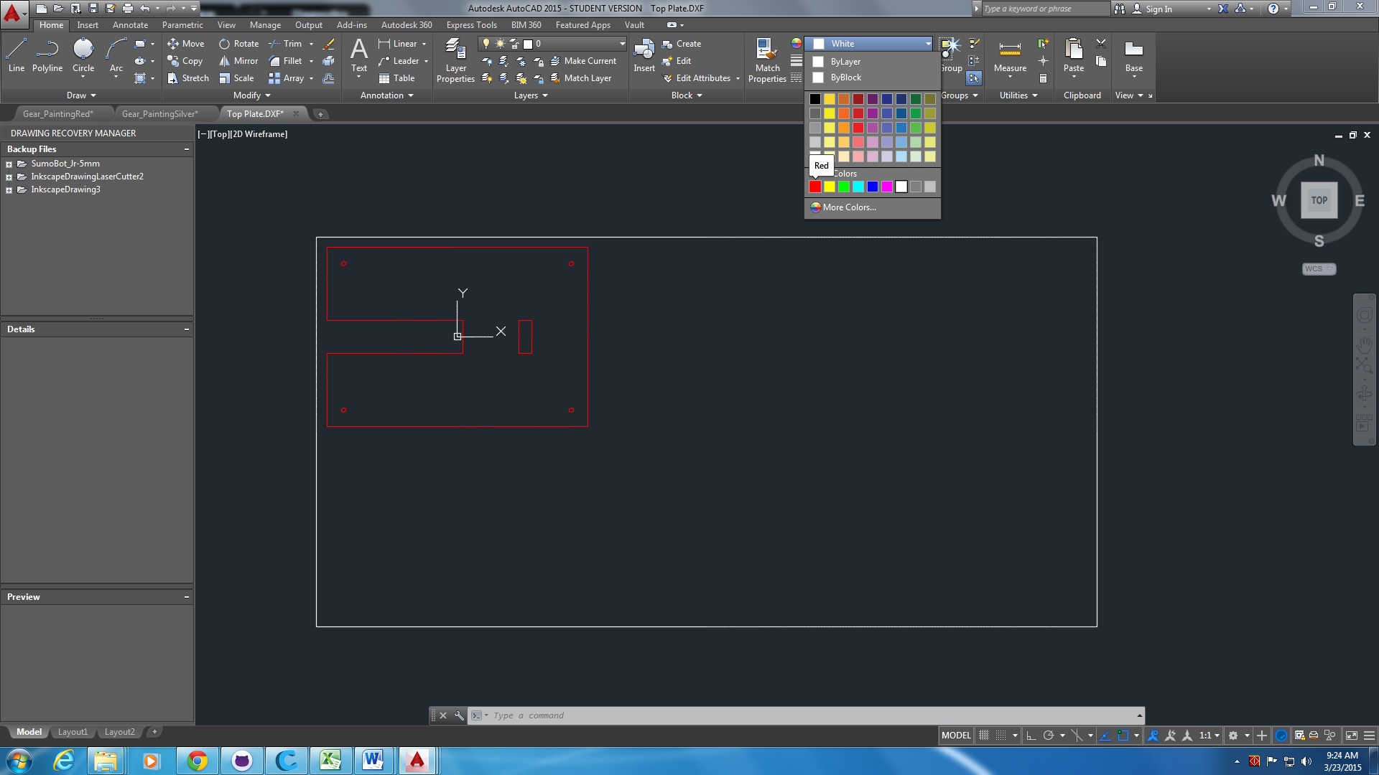

Make the outside cuts happen after inside cuts:

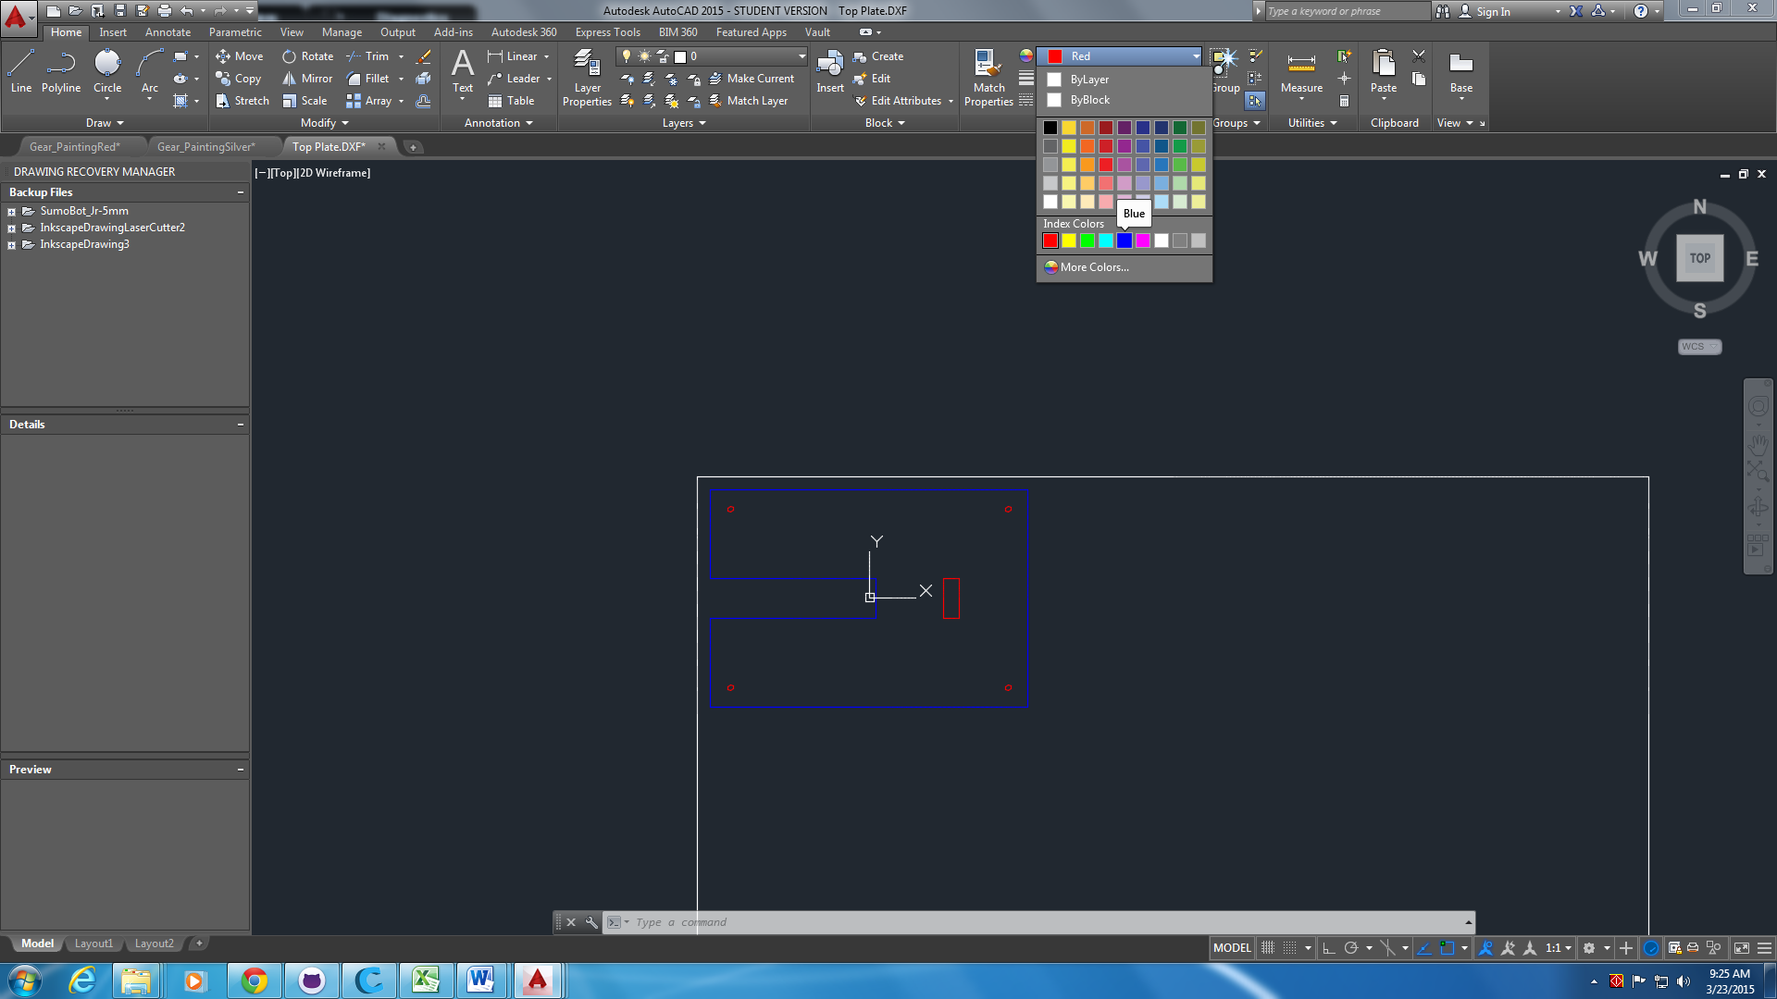

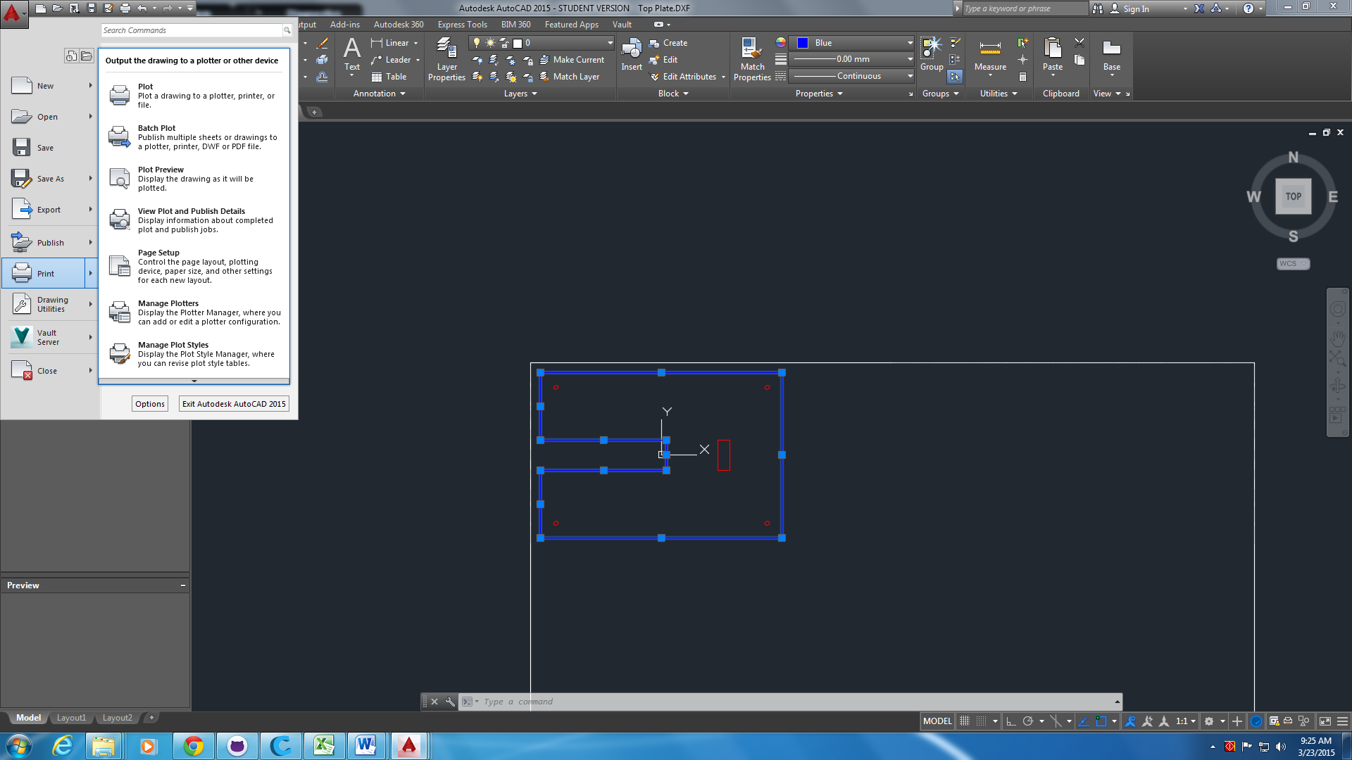

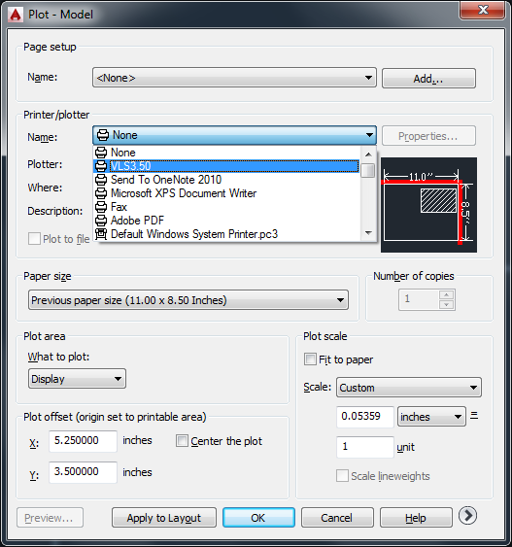

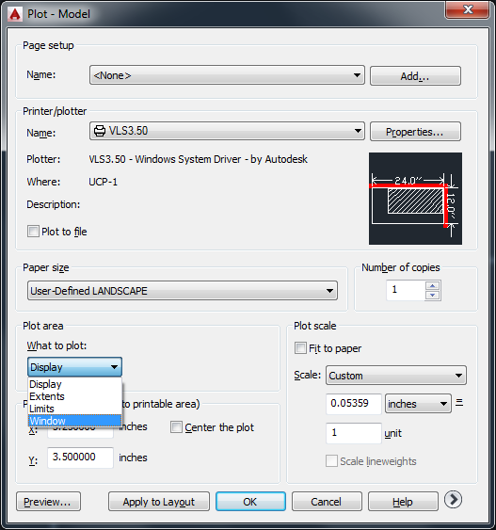

Then click on the top left and bottom right corners of your white rectangle (24”x12”)

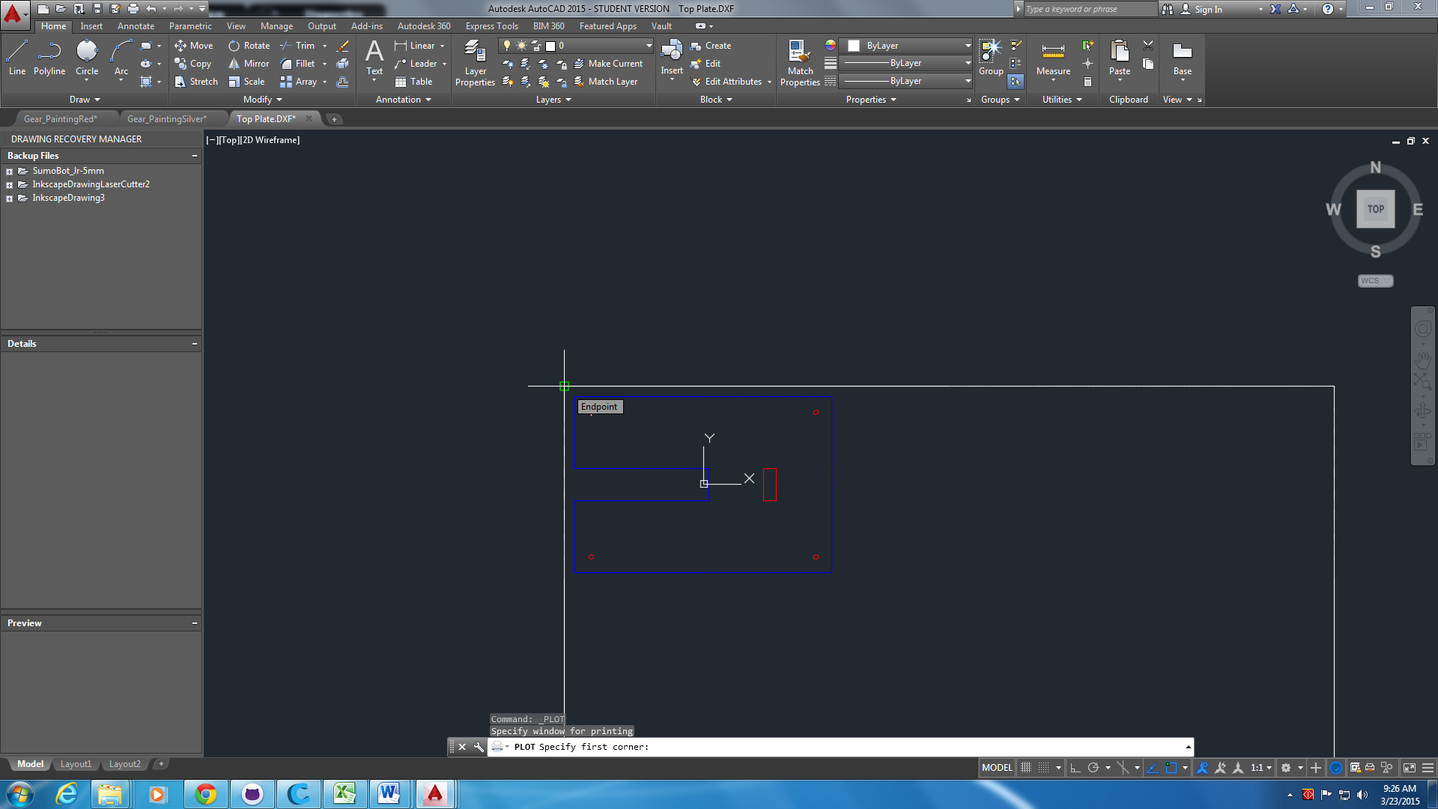

Set the line colors you want to print:

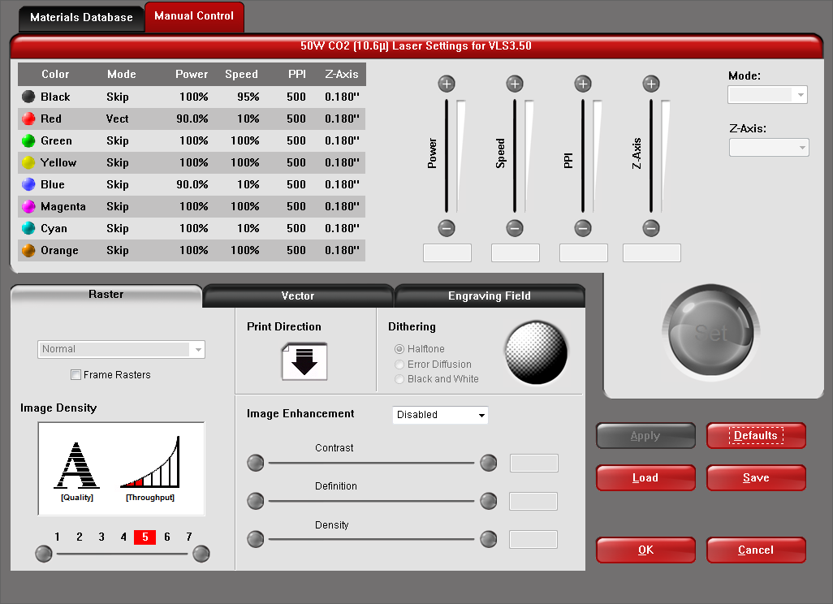

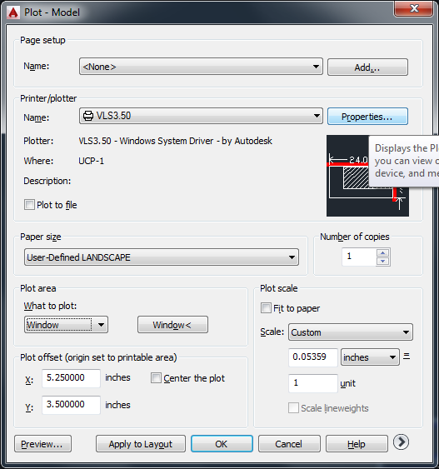

Plot area: window (click the corners to match your white rectangle)

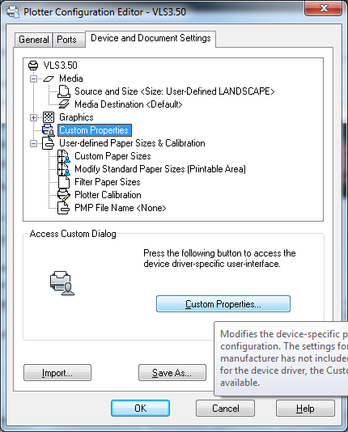

We have red and blue lines, so select these and set the **mode** to Vector

Make sure the PlotScale matches your units

Center the plot:

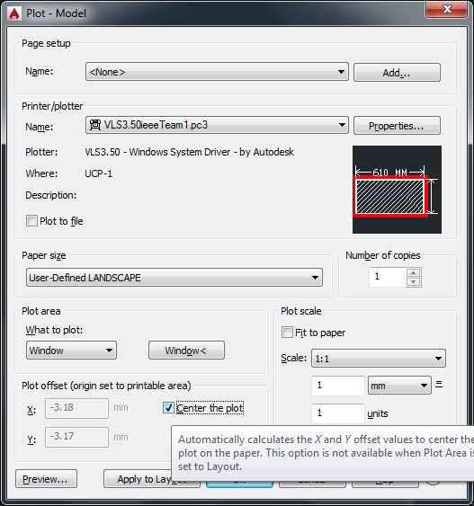

Plot scale, use the scale of your drawing (cm, mm, inches)

Center the plot

You may find it helpful to save your profile. Pick a unique name

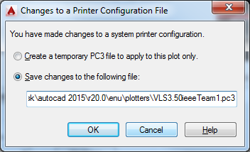

Go to the universal laser (bottom right icon)

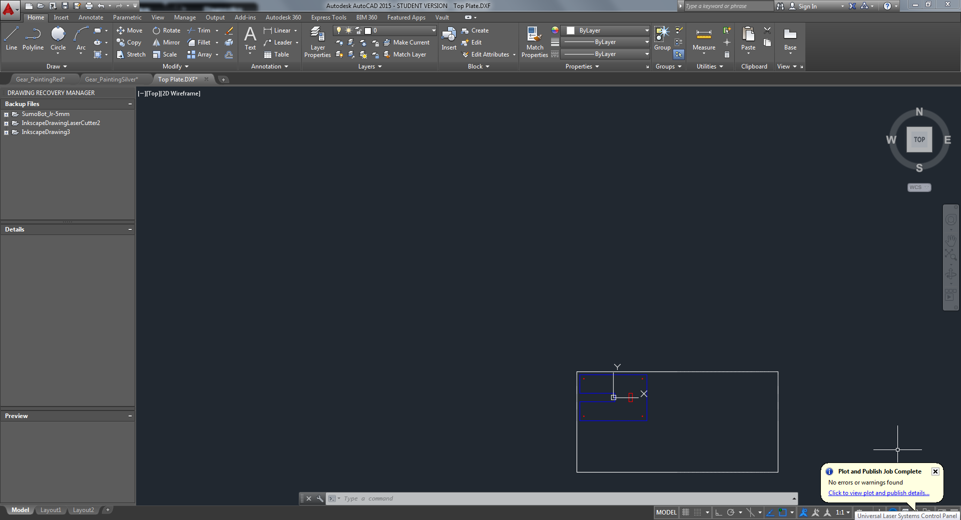

Use the depth gauge to set the correct depth for the laser. Be careful with the height adjustment.

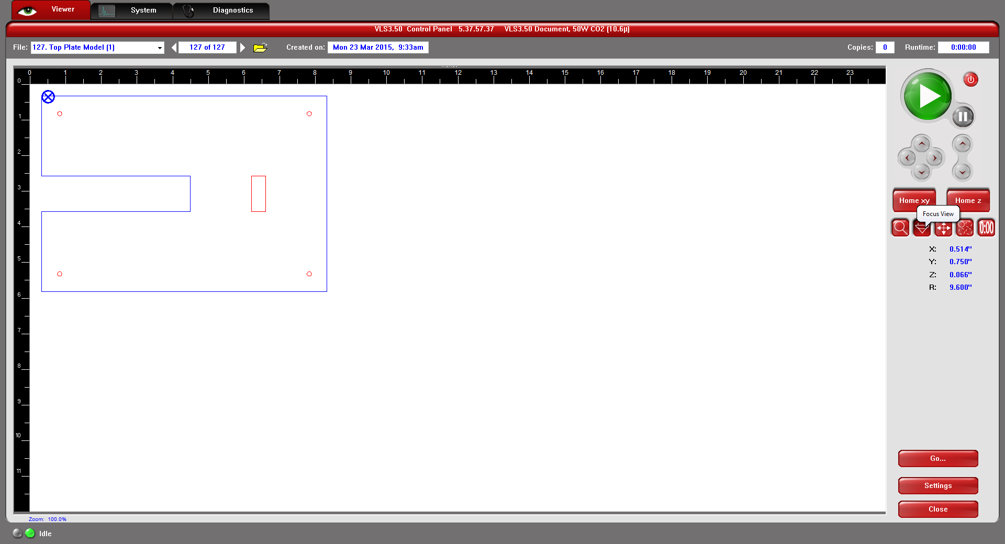

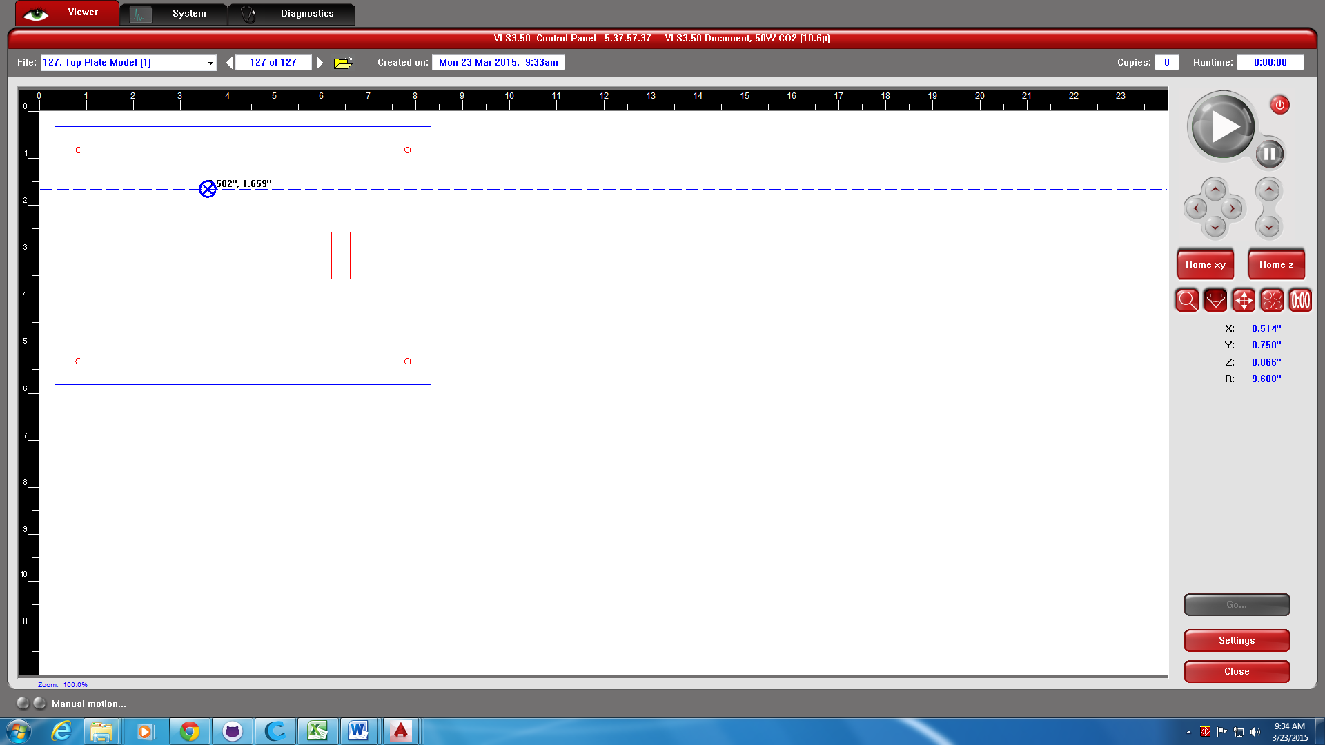

Now use the settings in the file:

C:\LaserParts\Laser Cutter Settings.doc

If your material doesn’t exist, you must do some trial cuts. It is best to always do trial cuts before cutting your parts.

.

# Placing parts into the scanner

Open the scanner by lifting in the middle the lid.

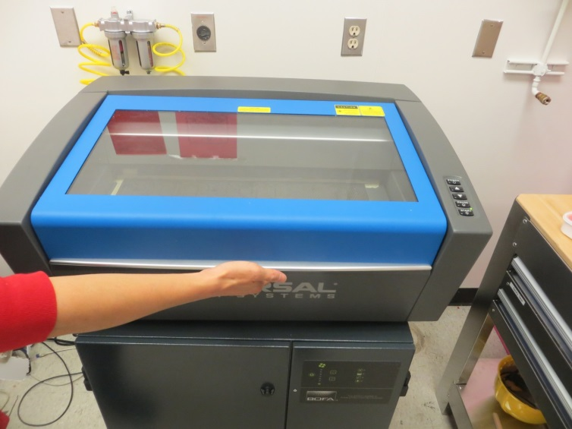

Place your material in the top left of the tray.

Turn the laser cutter on, using the power button on the UI screen.

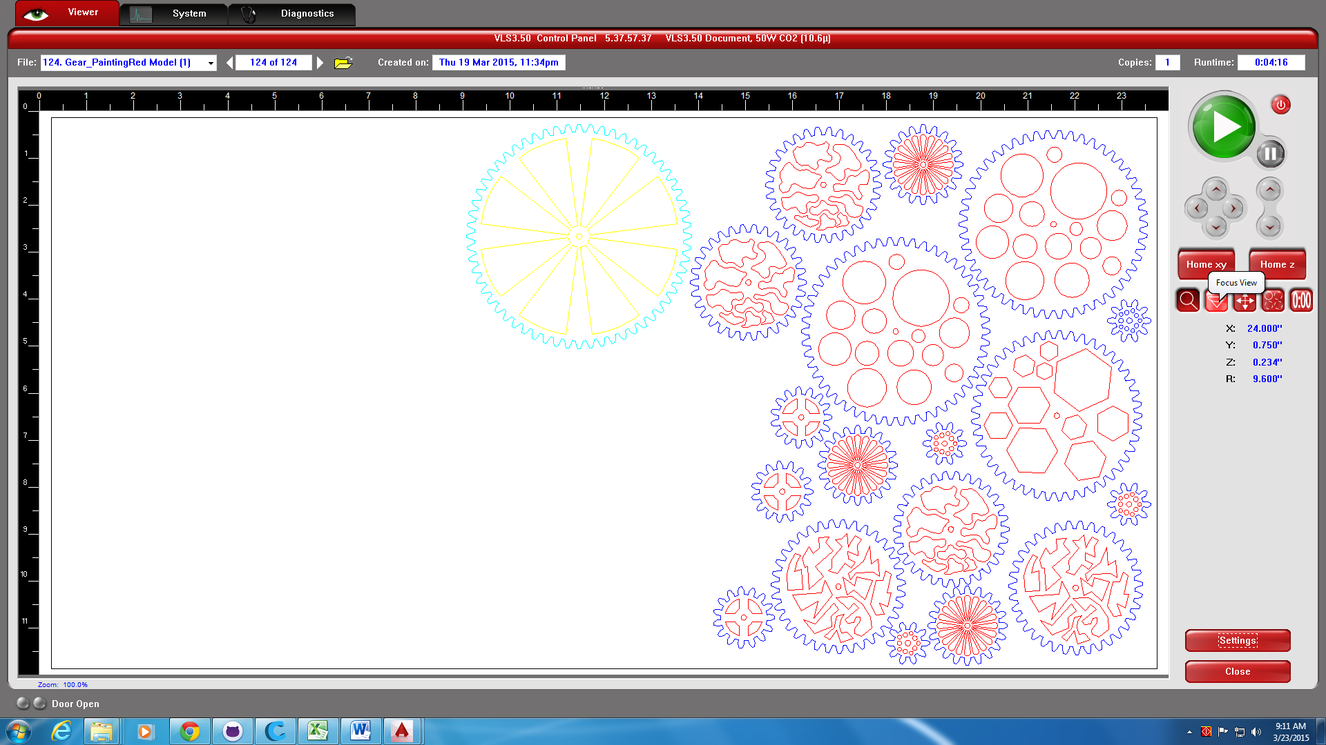



You must set the depth correctly using the black and white jig. The jig is in the laser cutter parts box.

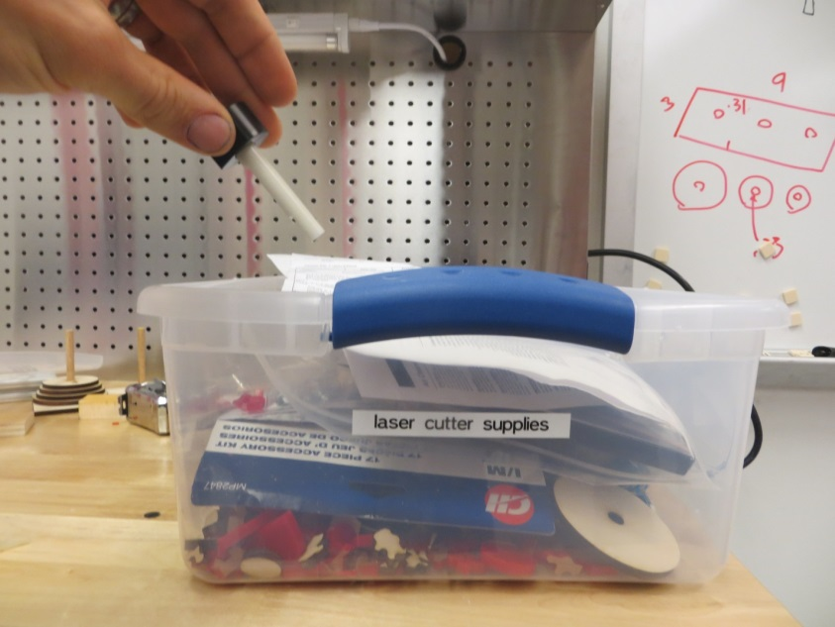

Set the jig such that the notch is under the red cover shown in the picture.

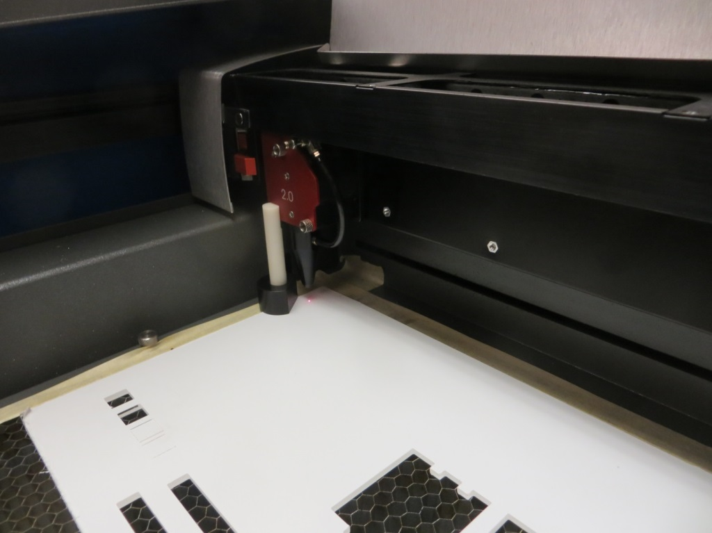

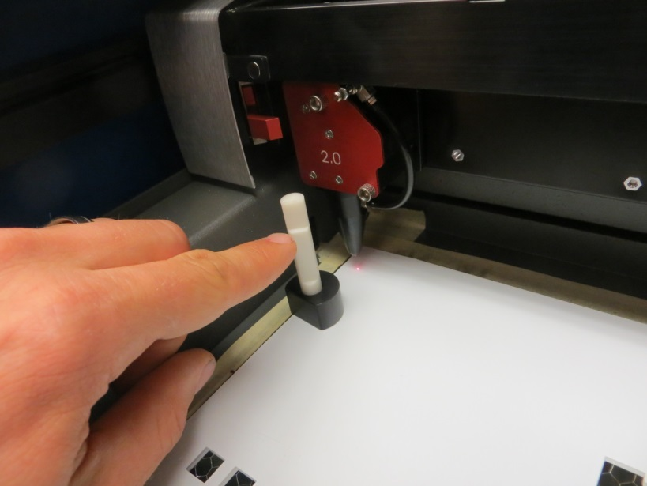

Use the up and down buttons on the laser cutter to adjust the height of the table to match the jig.

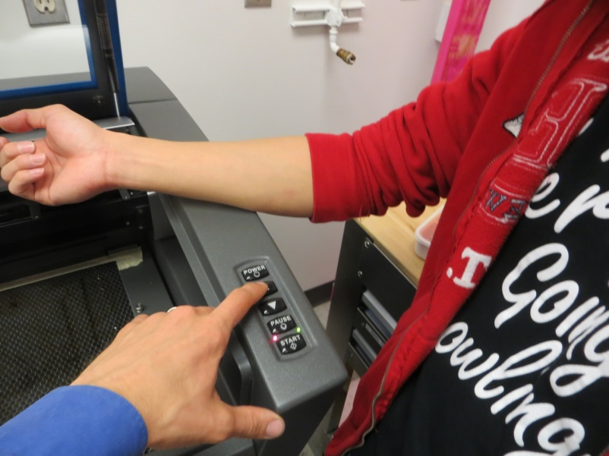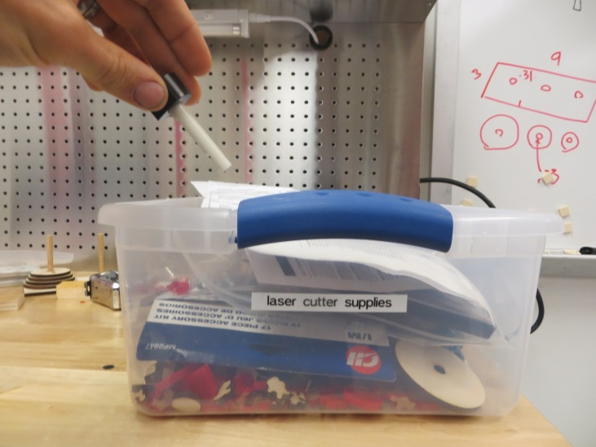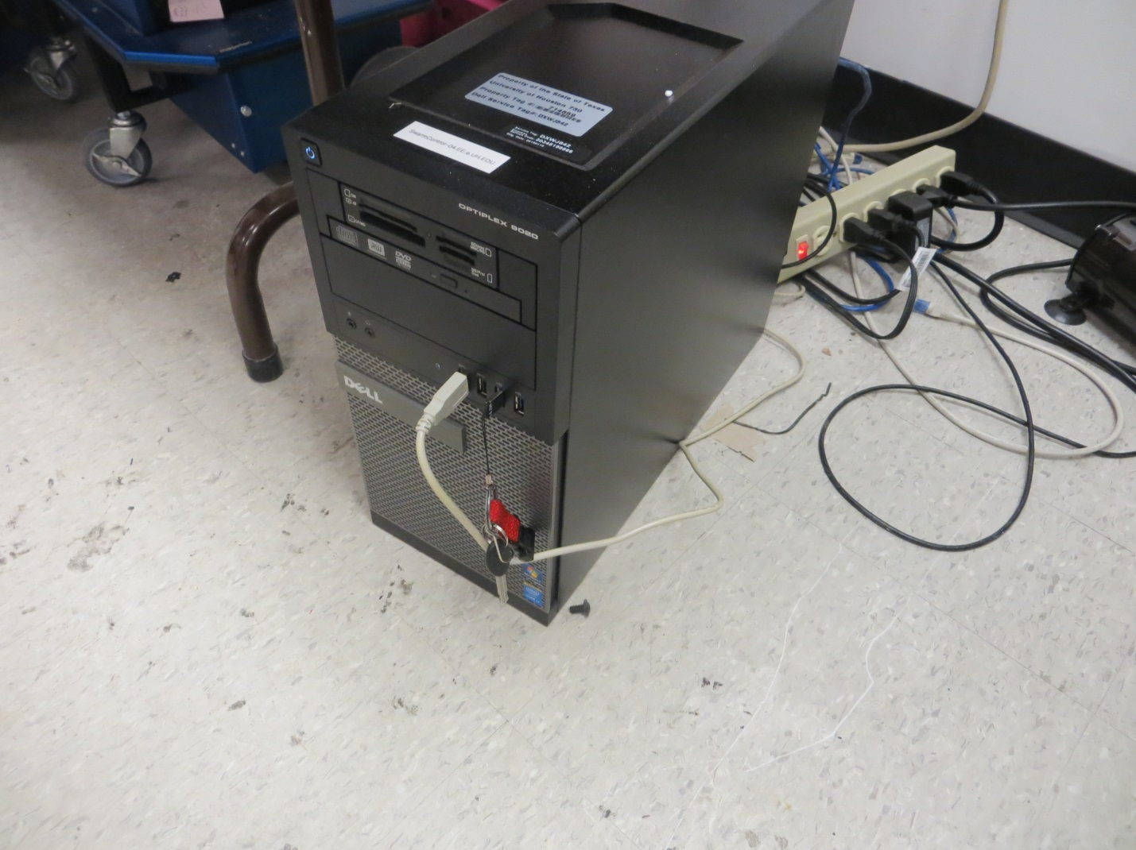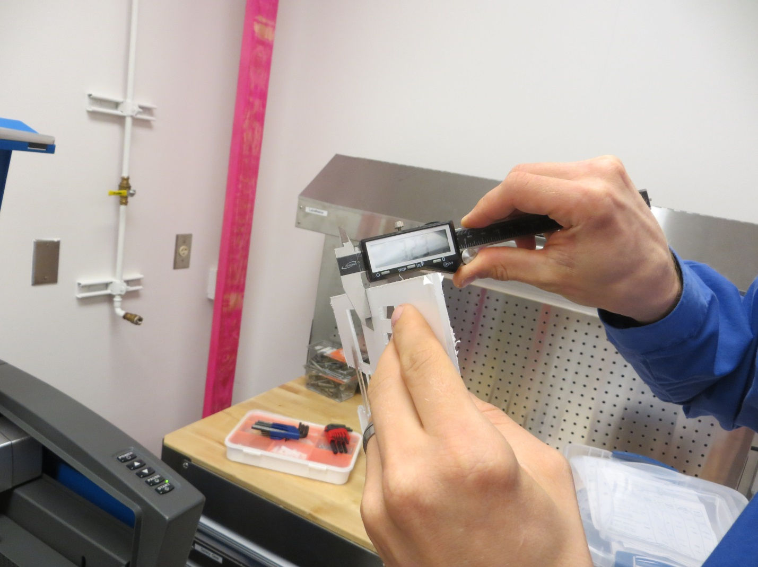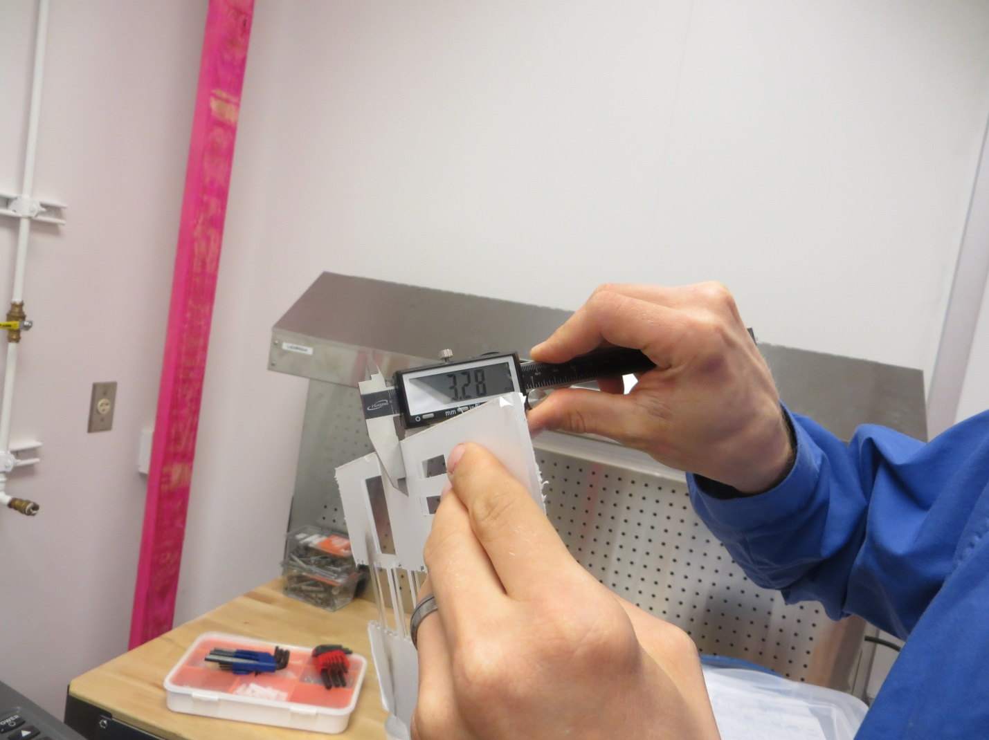

Turn on the small pump on the floor near the back of the laser cutter.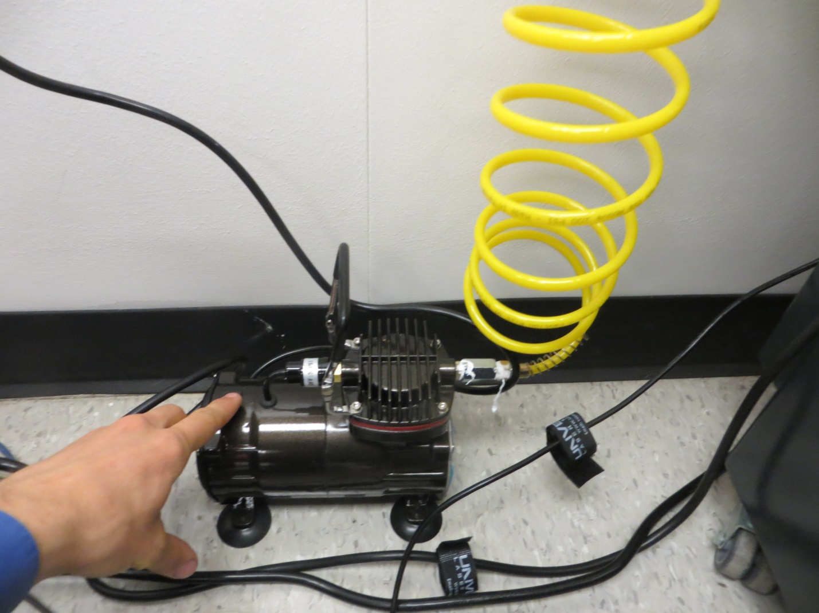Adjust the diverter on the wall behind the laser cutter.

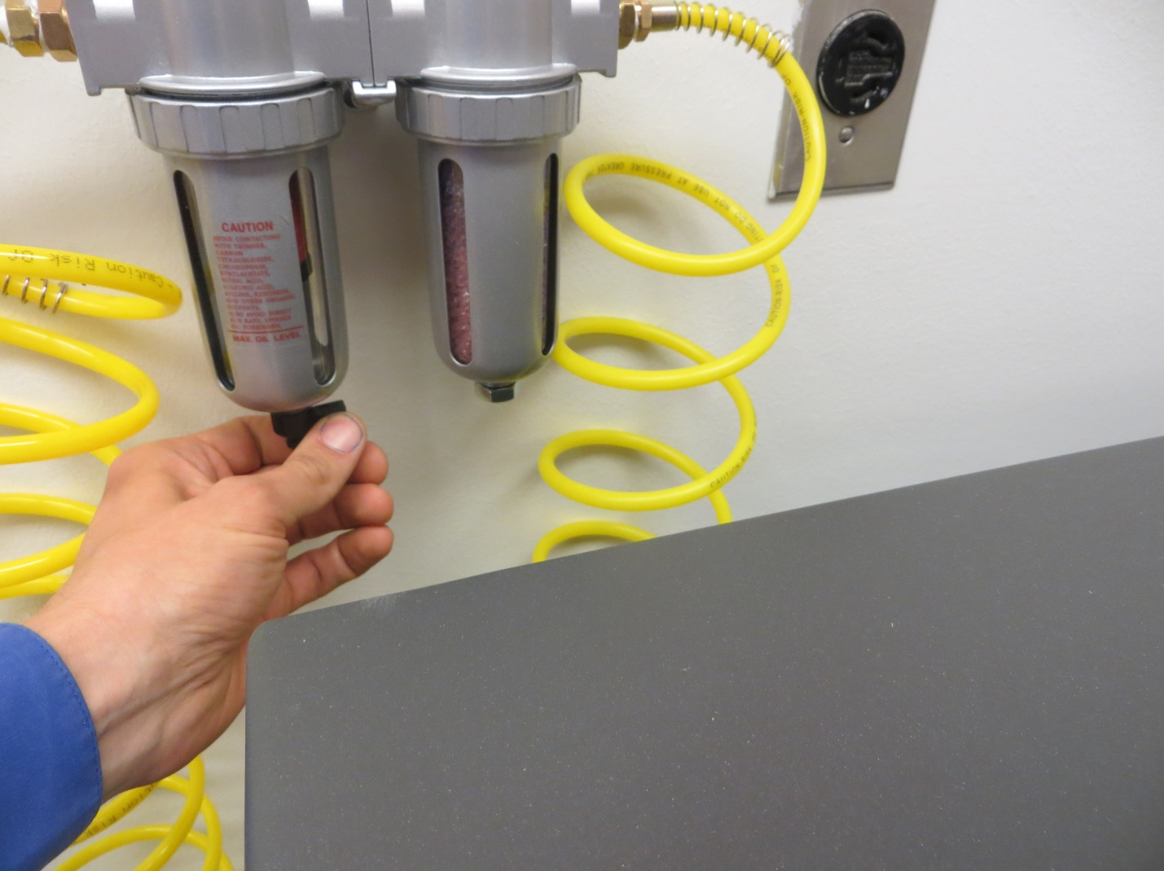Briefly stop the bottom of the diverter with a finger until the suction stops.

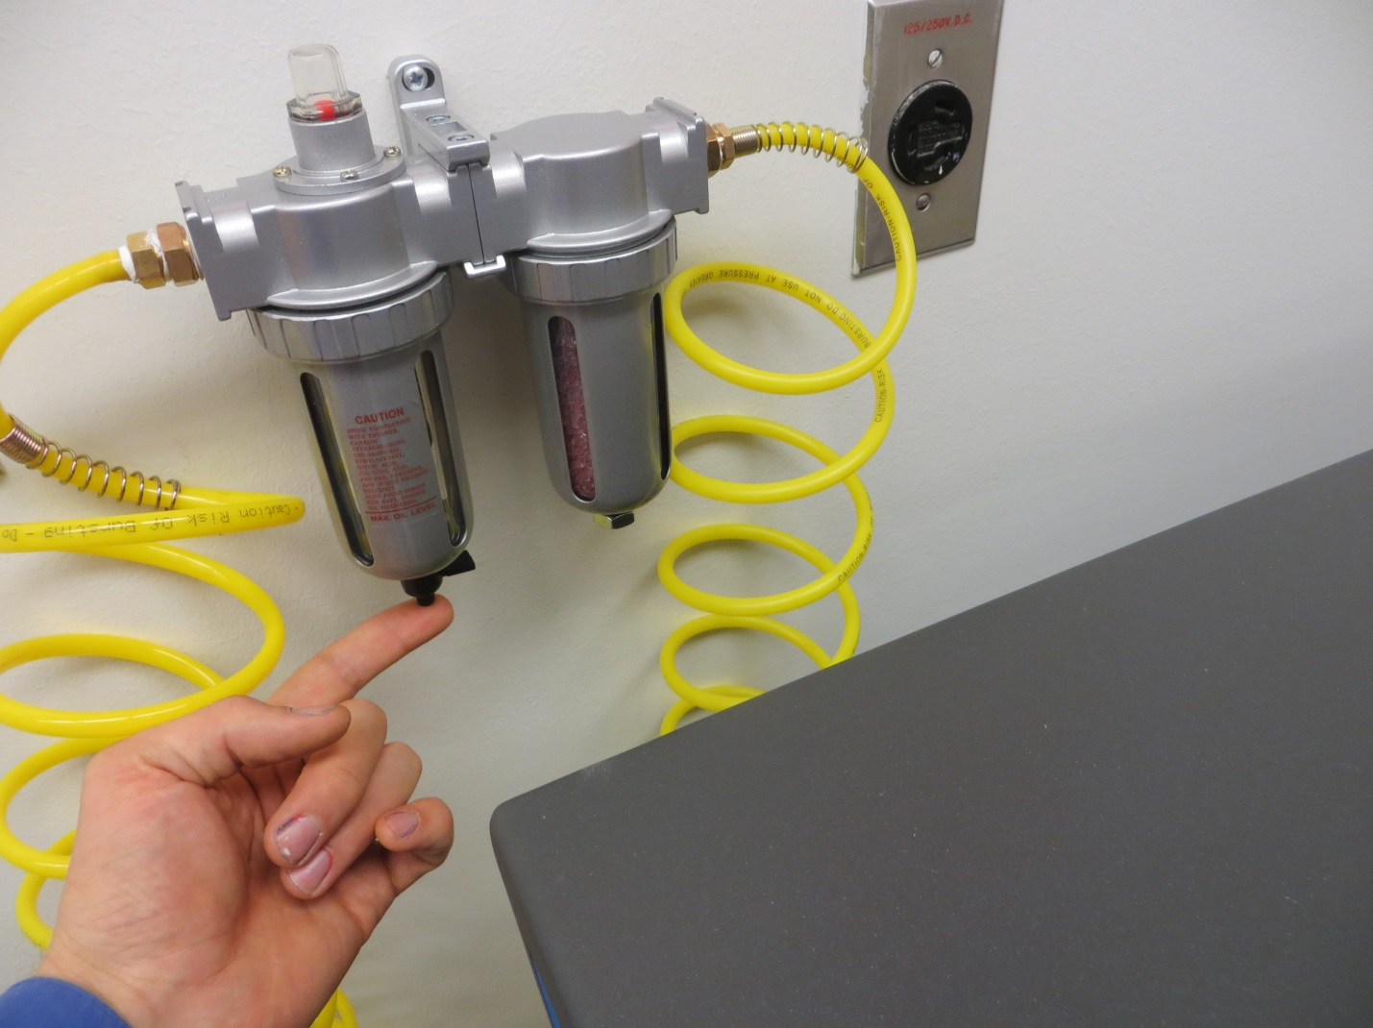Turn on the exhaust equipment beneath the laser cutter.

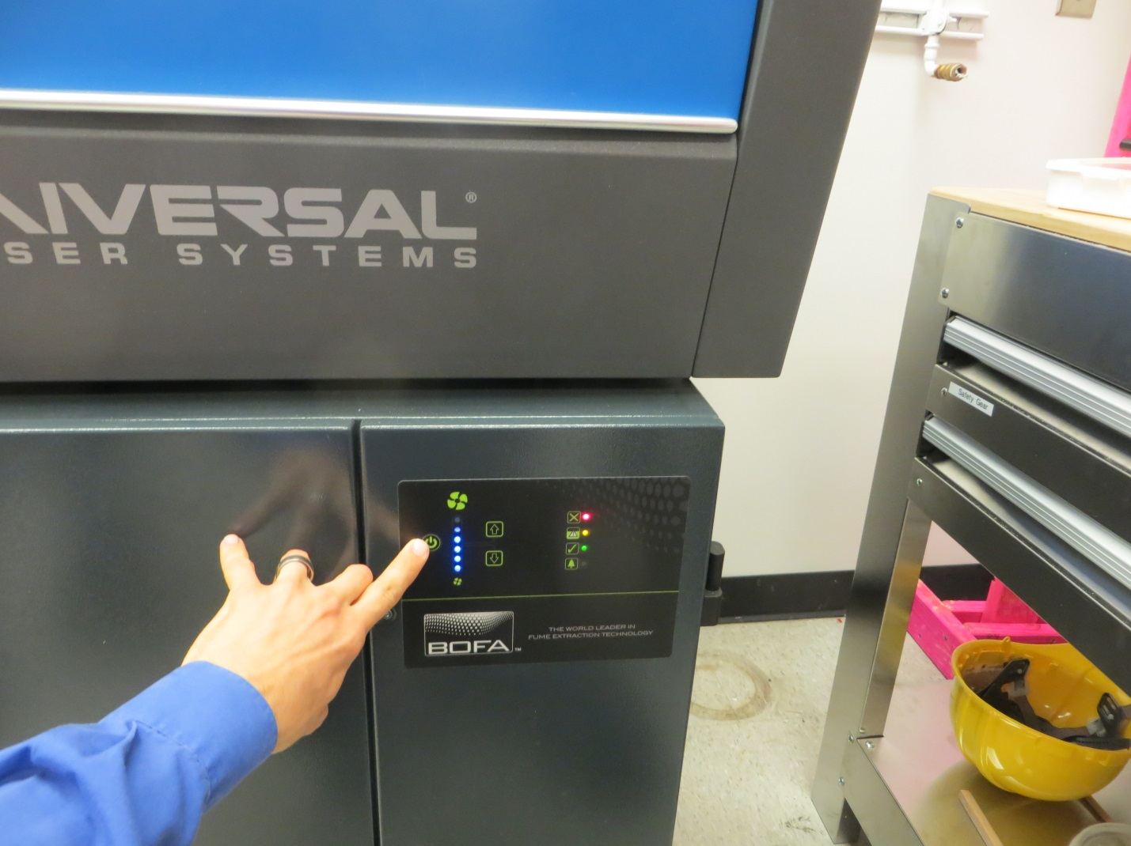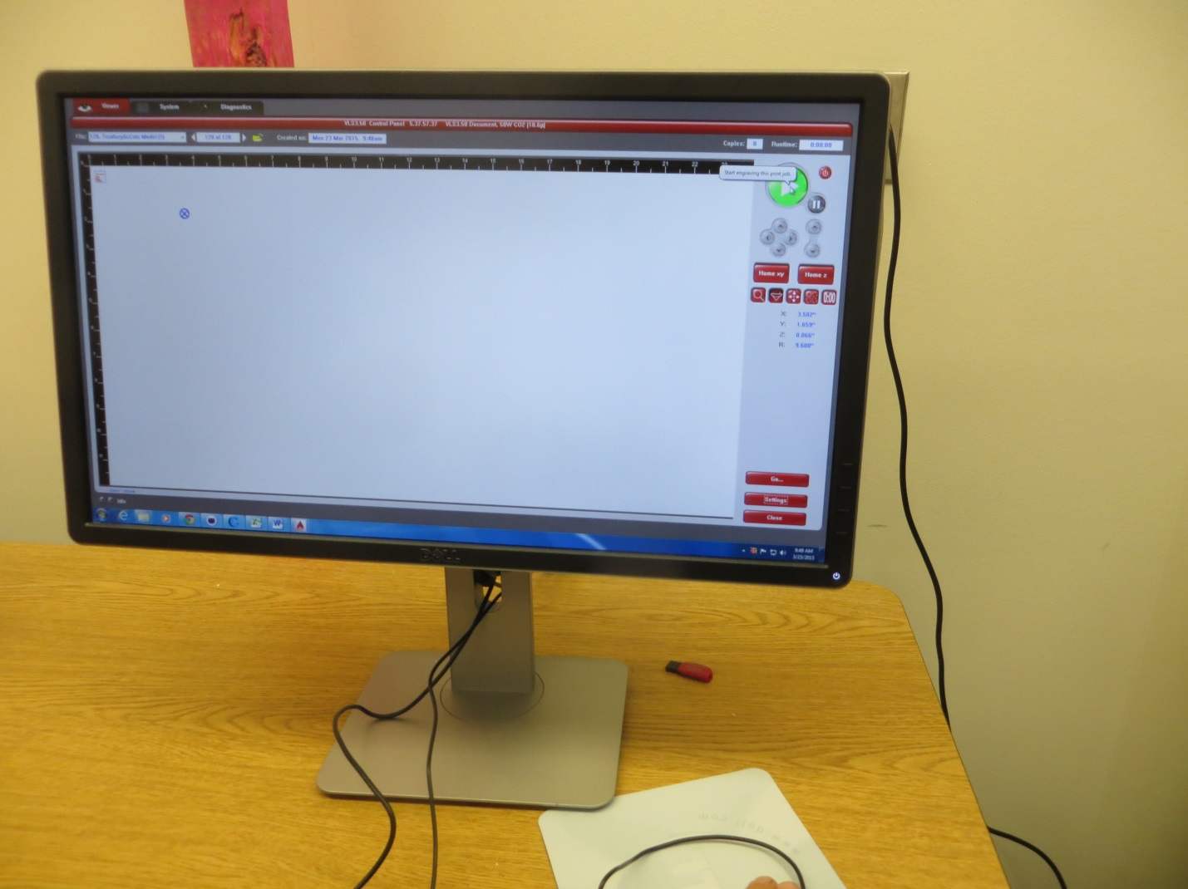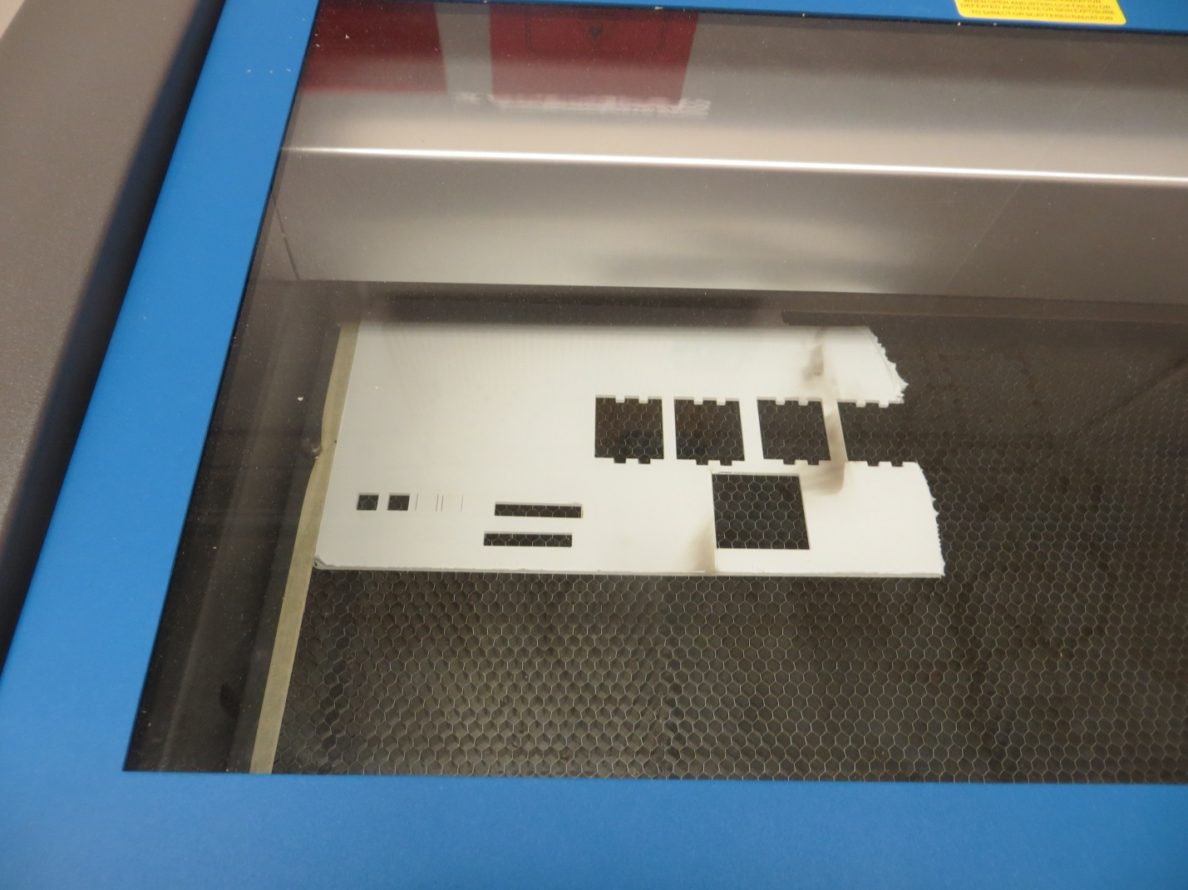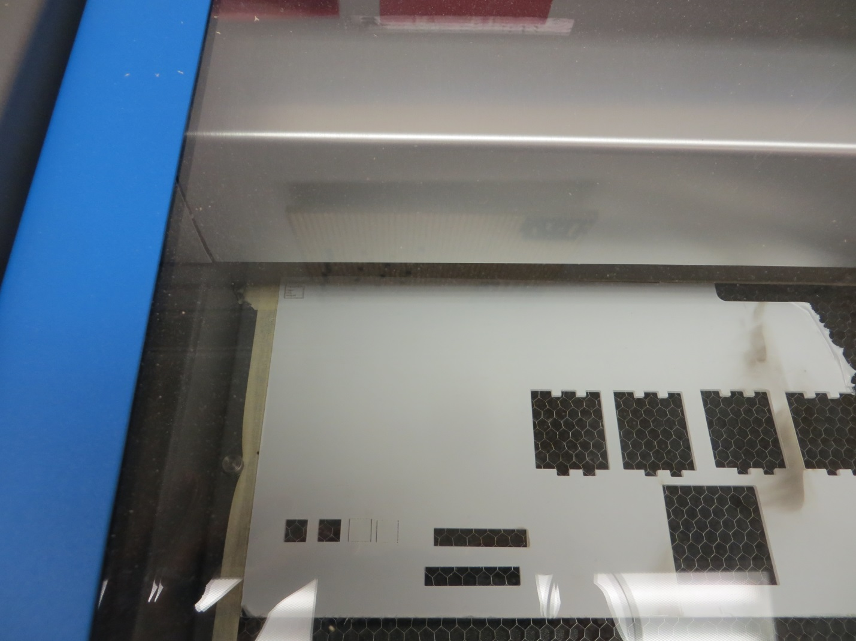When cutting is complete, turn off the exhaust equipment.

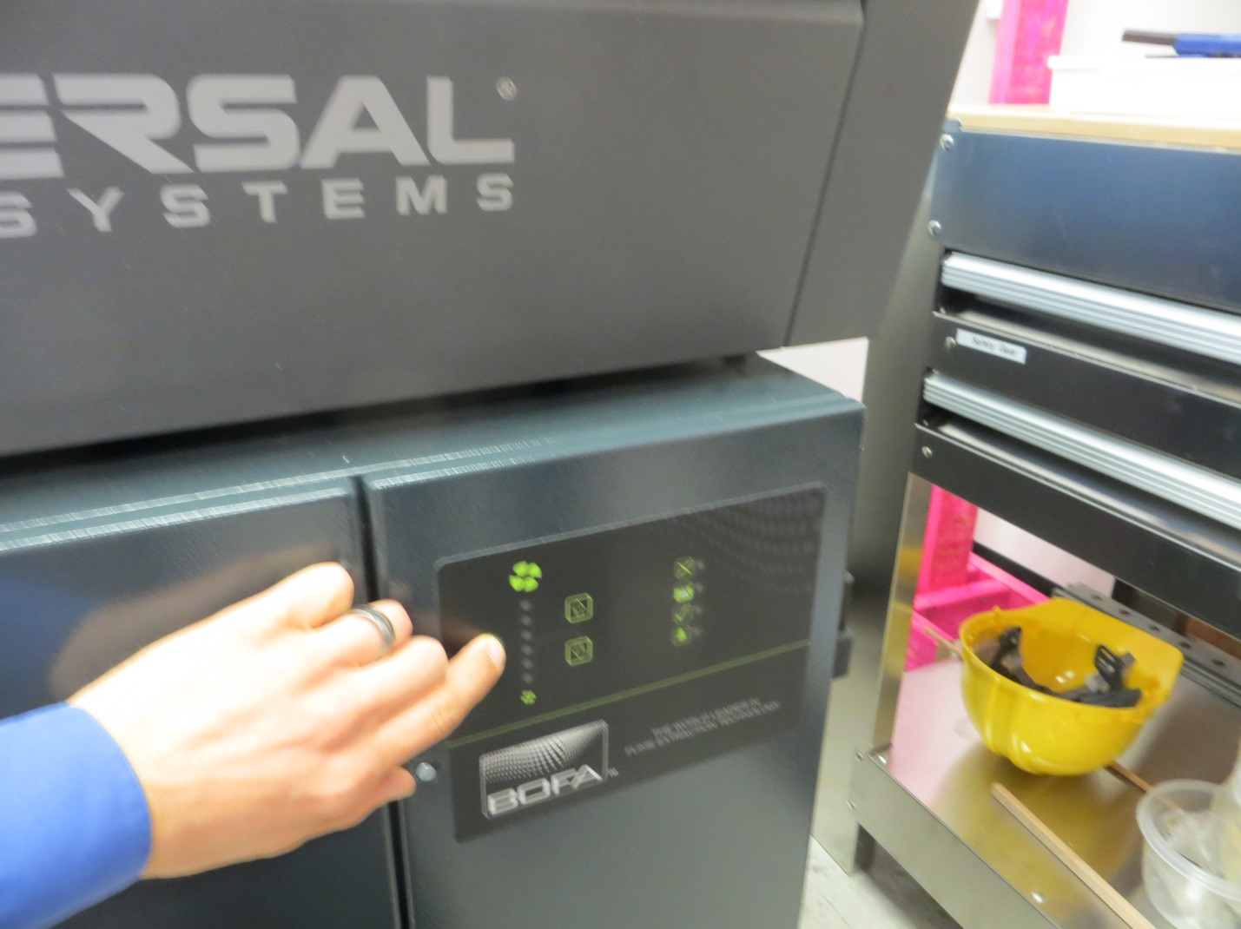Turn off the diverter.

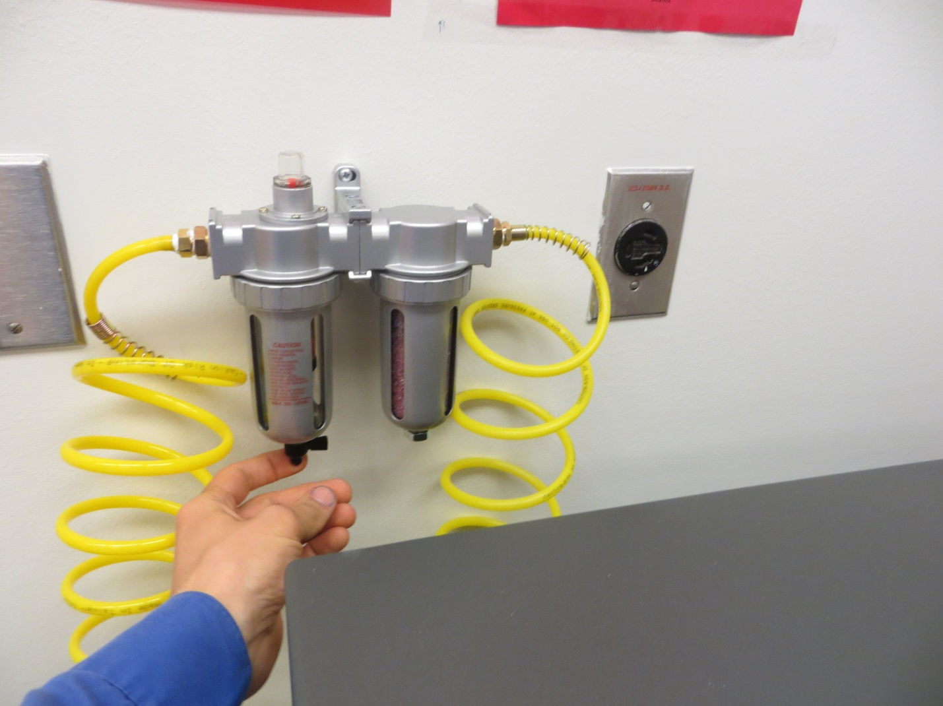Turn off the pump.

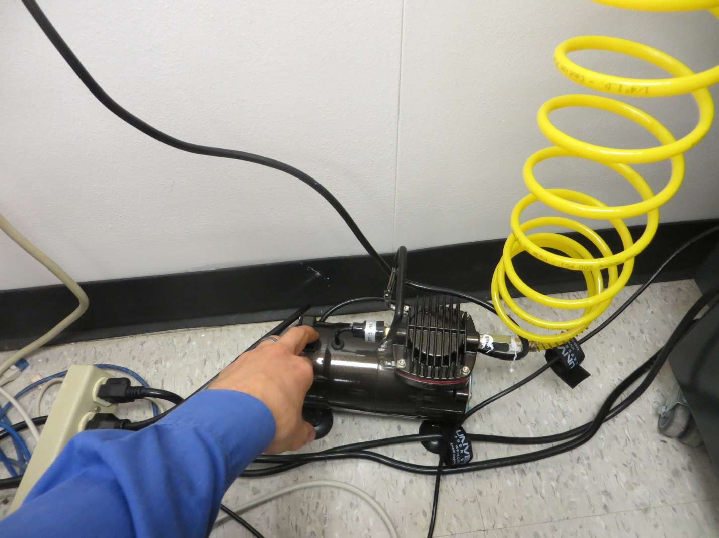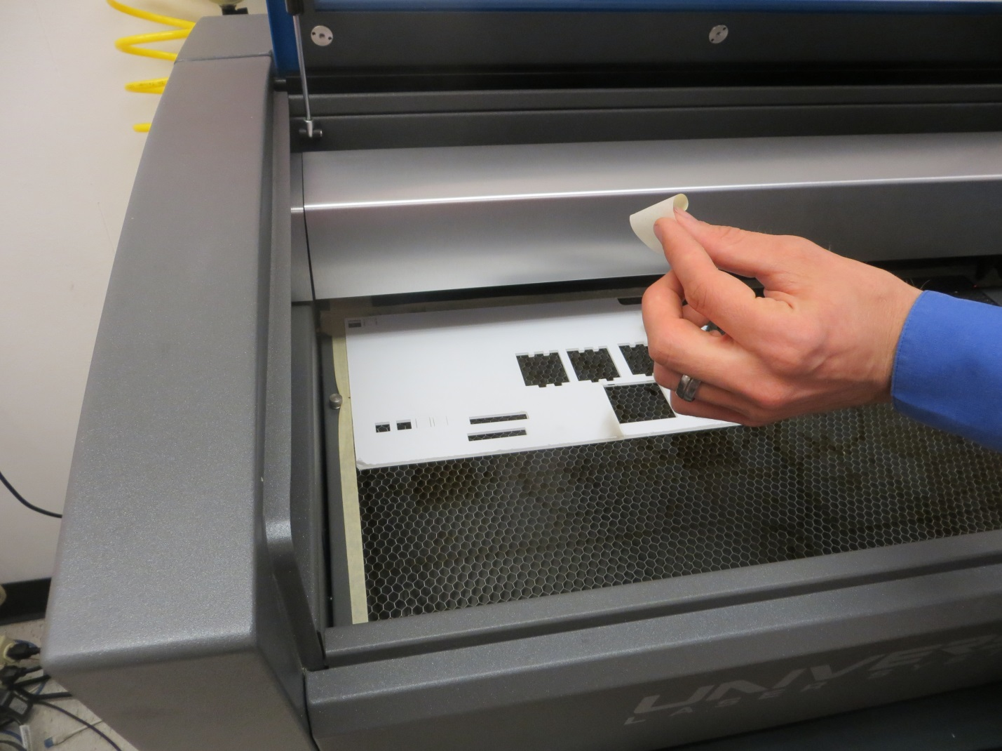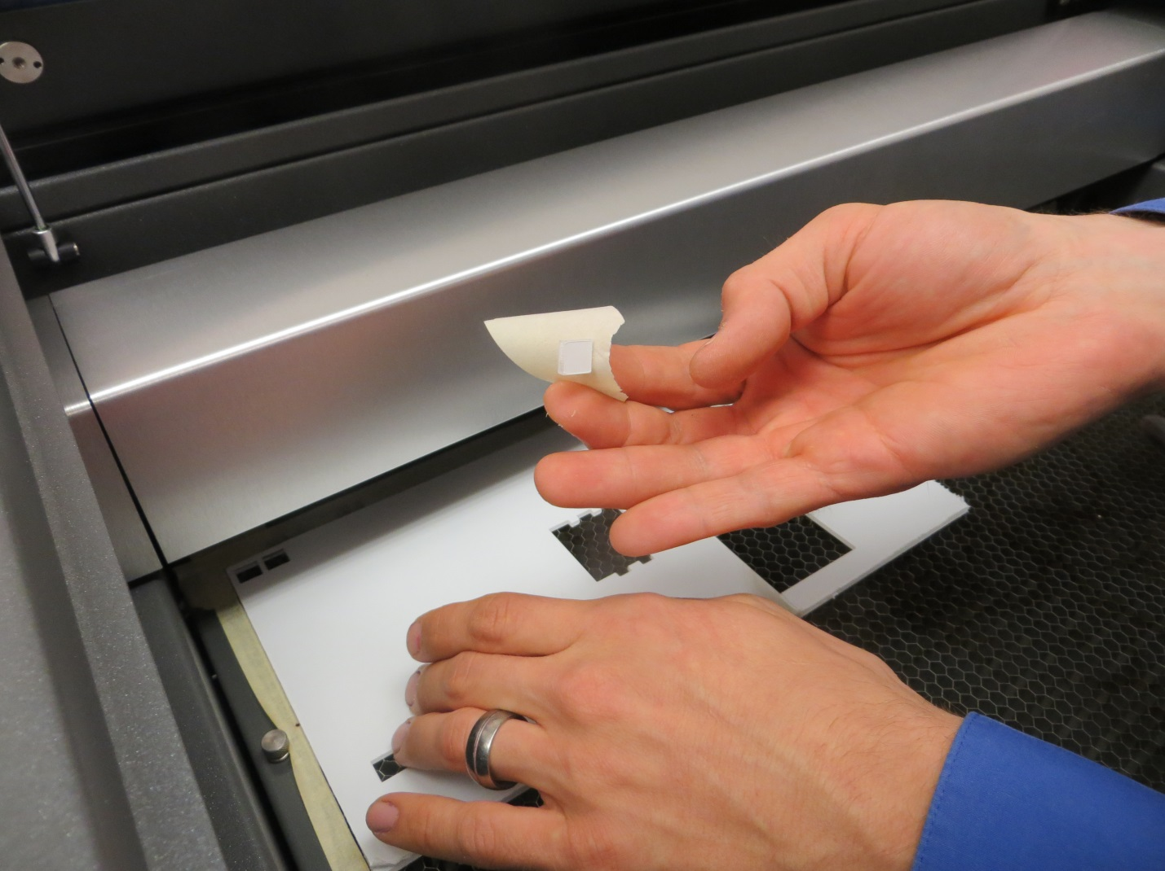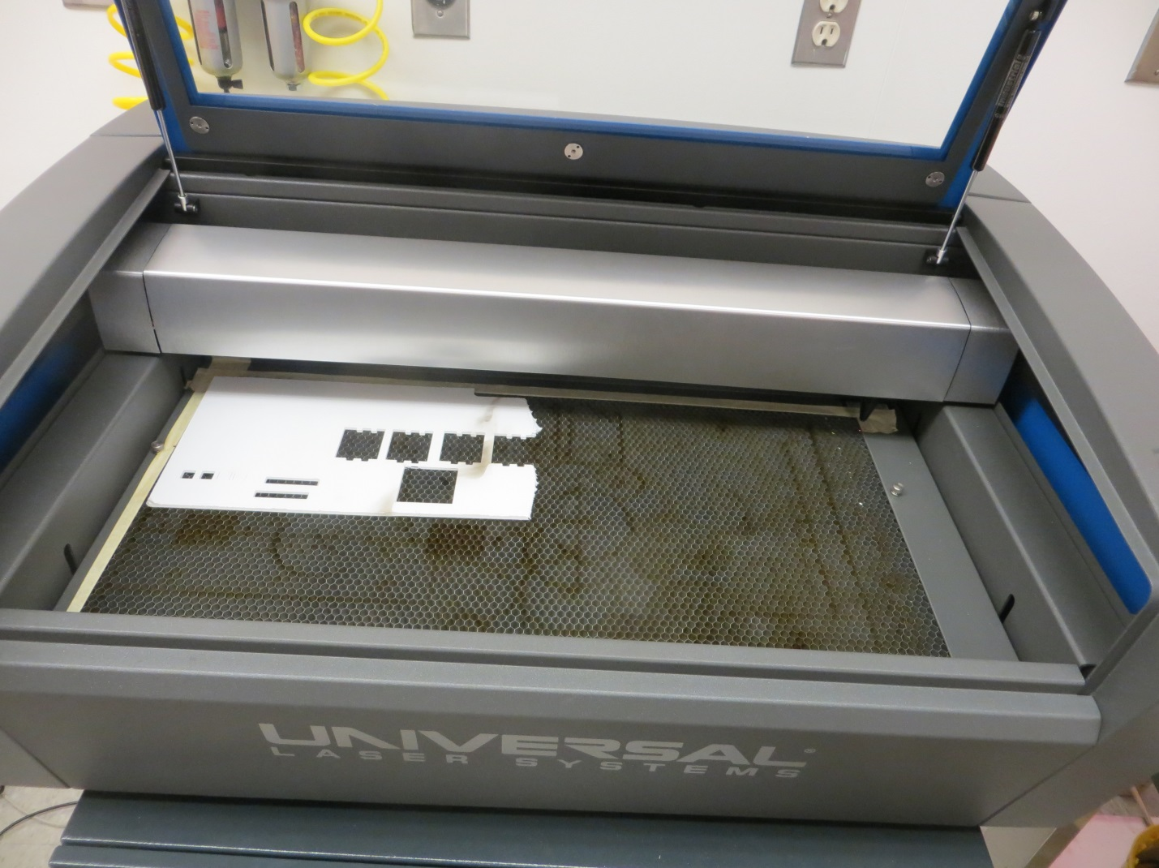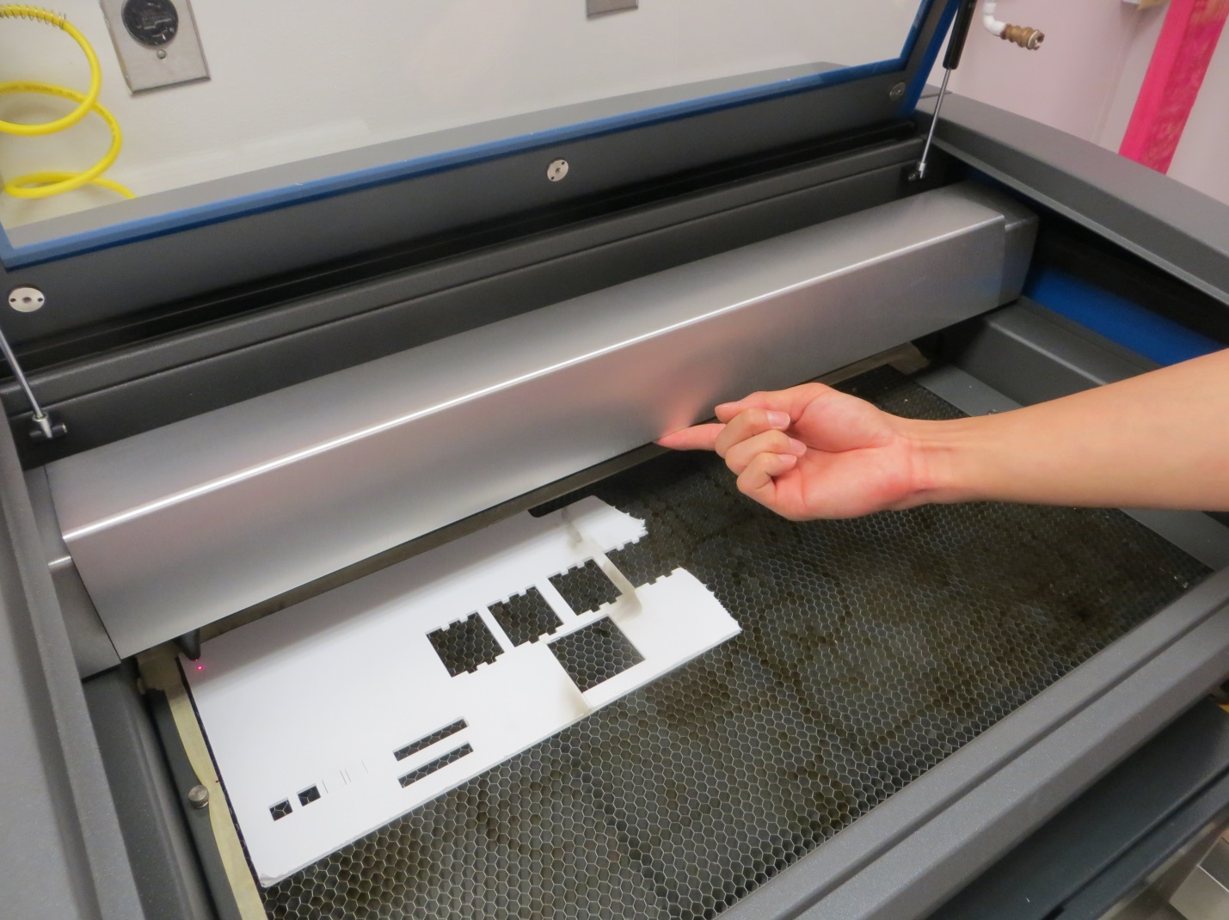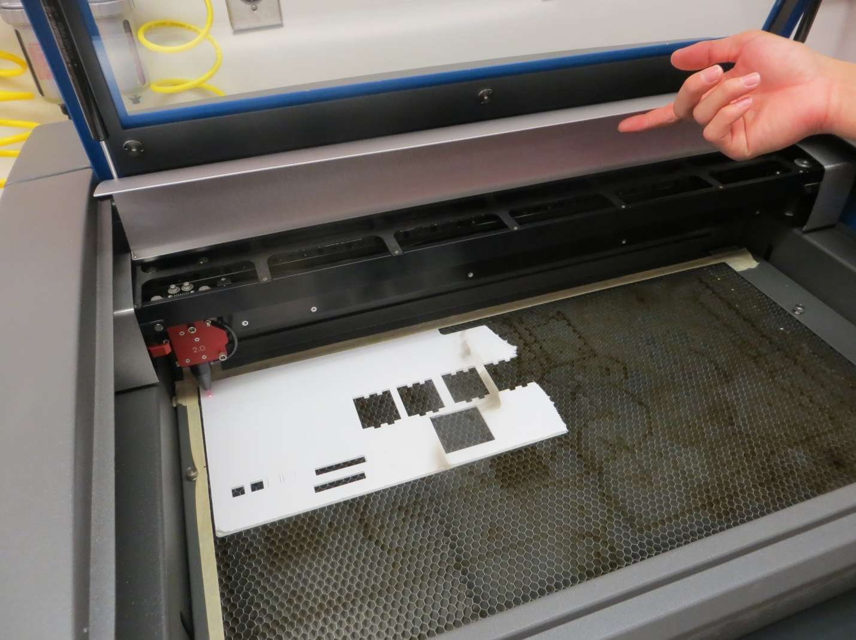

Vector cutting depth and raster engraving depth (or marking intensity if you are surface marking only) are controlled by specifying the speed of processing and the laser power level for raster engraving and by specifying the speed of processing, laser power level and number of pulses per inch (PPI) for vector cutting and marking. These parameters are specified in the printer driver printing preferences interface.

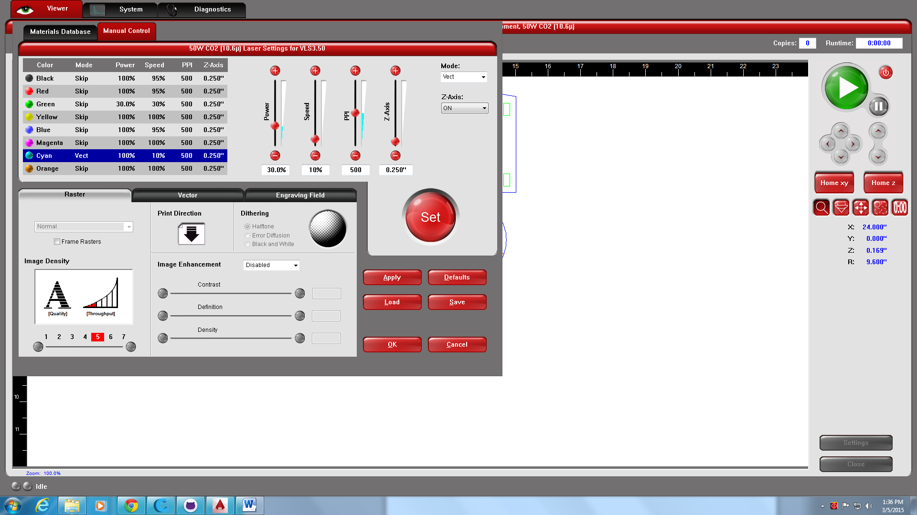

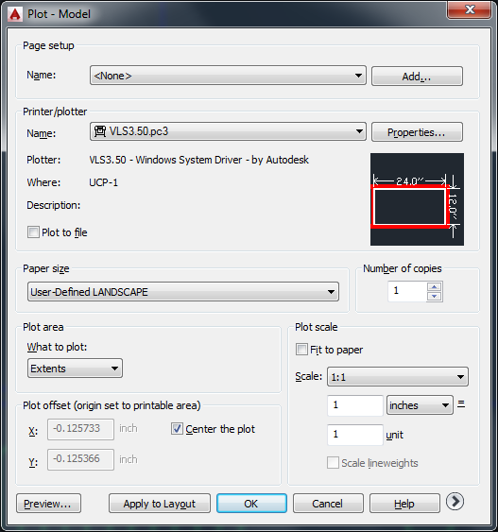 Priont Extends